**DBMS II Practical**

1. Write a PL/SQL block to display the message “hello world”

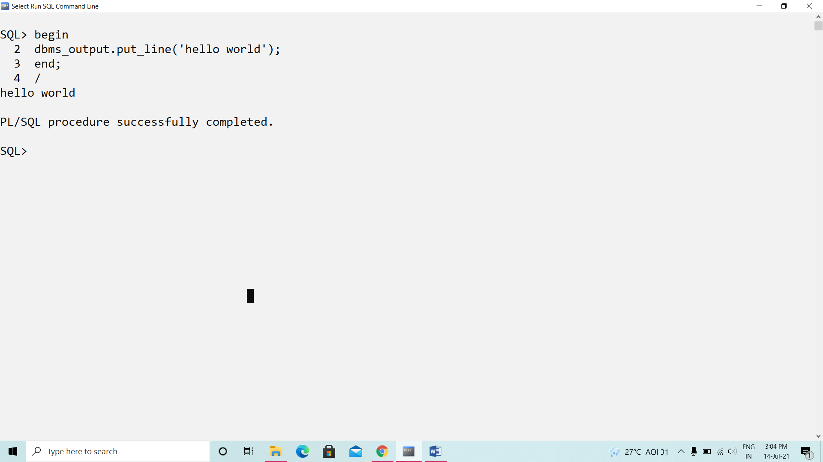

1. Write a PL/SQL block which will read a number from the user and display it on the screen.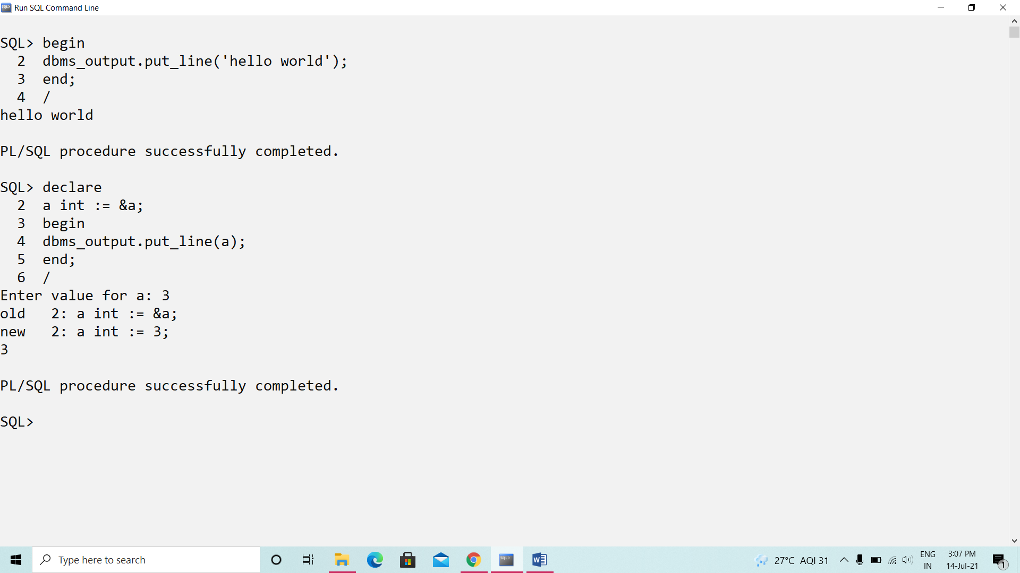
2. Write a PL/SQL block to read a message from user and display it

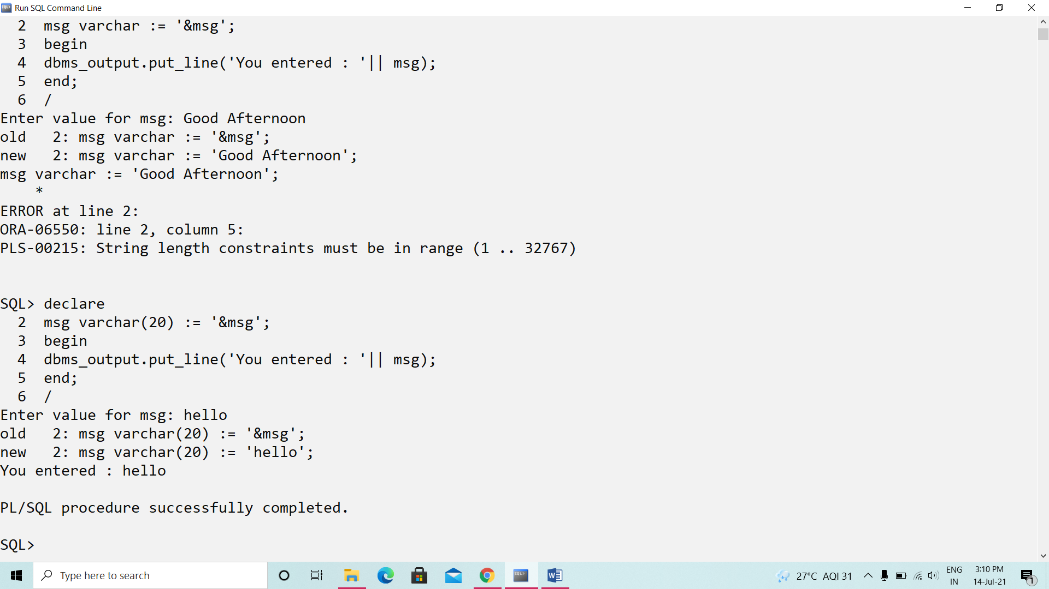

1. Write a PL/SQL block to display the area of rectangle when length and breadth are accepted by the user

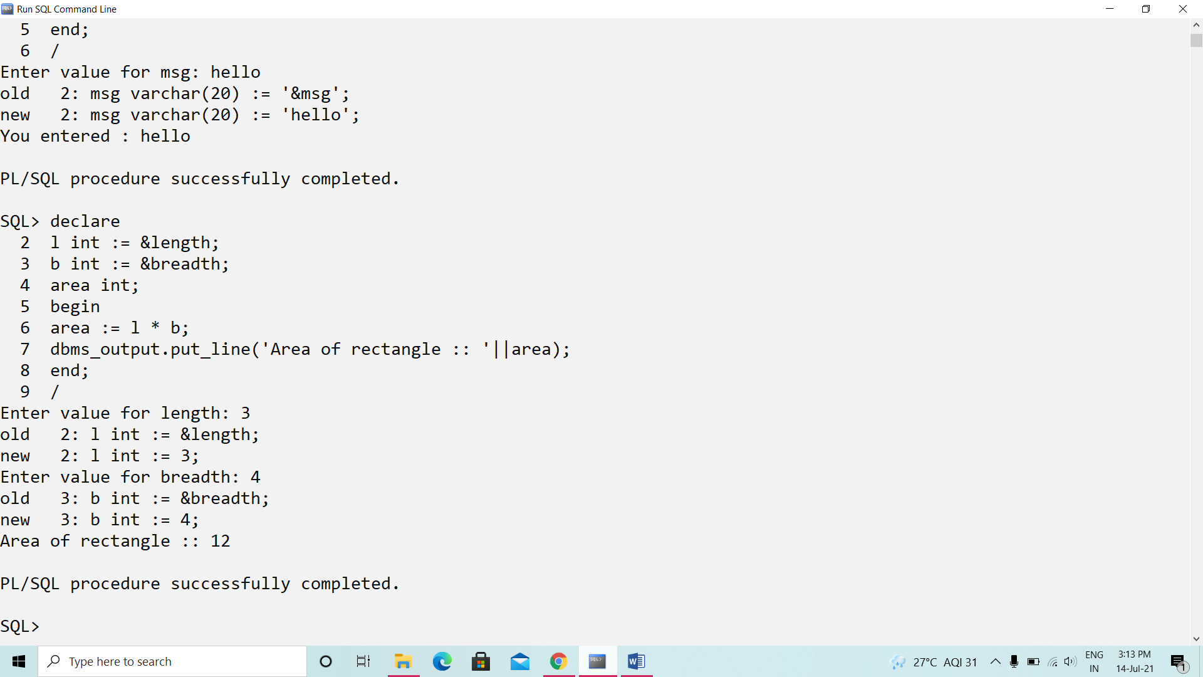

1. Write a PL/SQL block to display the total number of employees

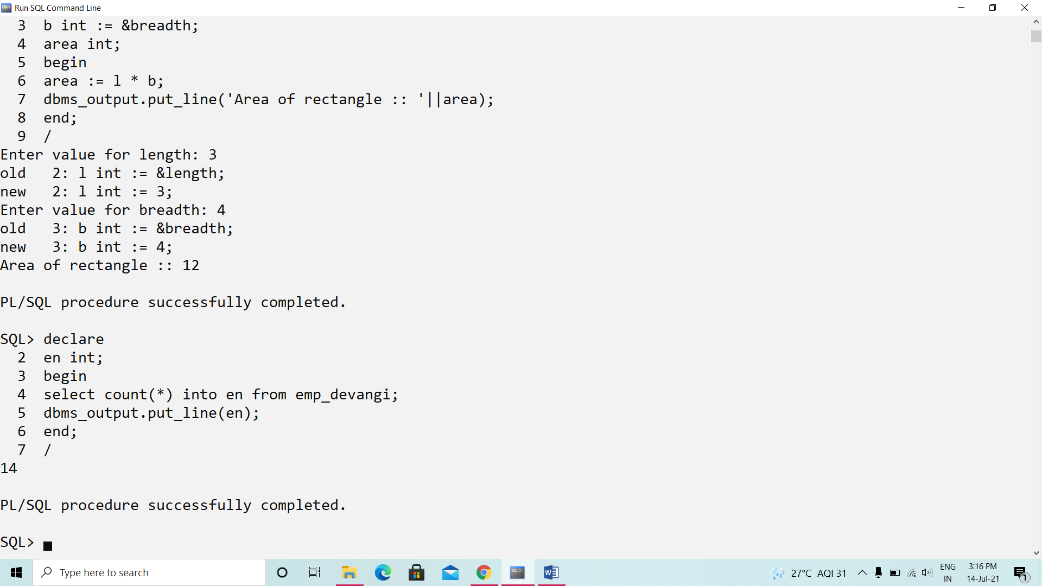

1. Write a PL/SQL block to print the sum of two numbers accepted by user

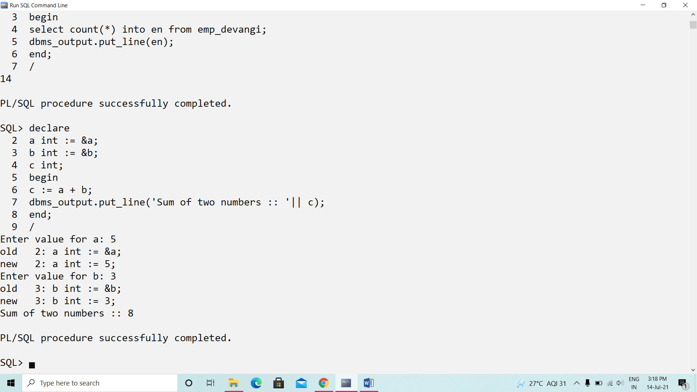

1. Write a PL/SQL block to print the message ‘you can lead a horse to water but you can’t make him drink’.

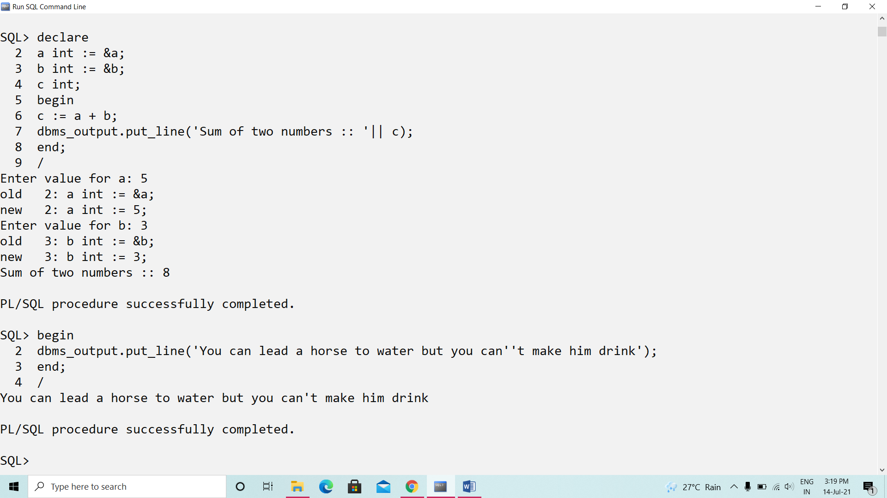

1. Write a PL/SQL block to print the name and job of an employee who is working as clerk earning salary of RS 1700

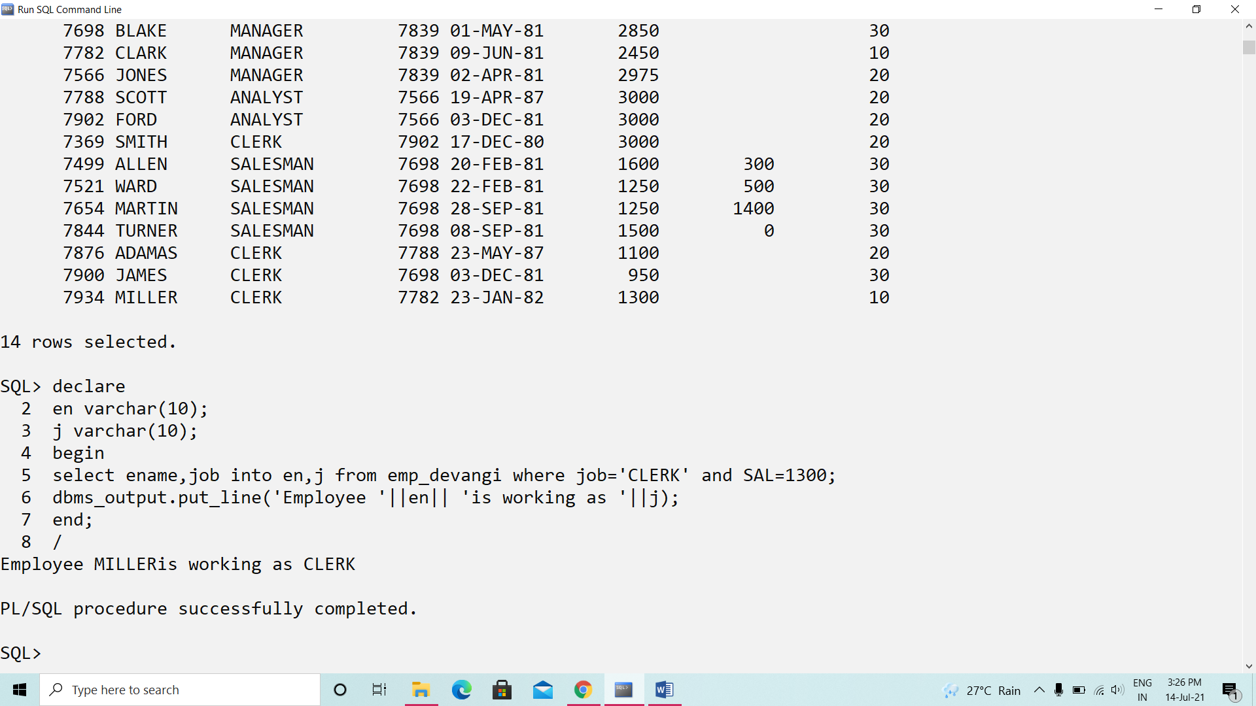

1. Write a PL/SQL block to calculate simple interest where principle, rate and time are accepted by the user

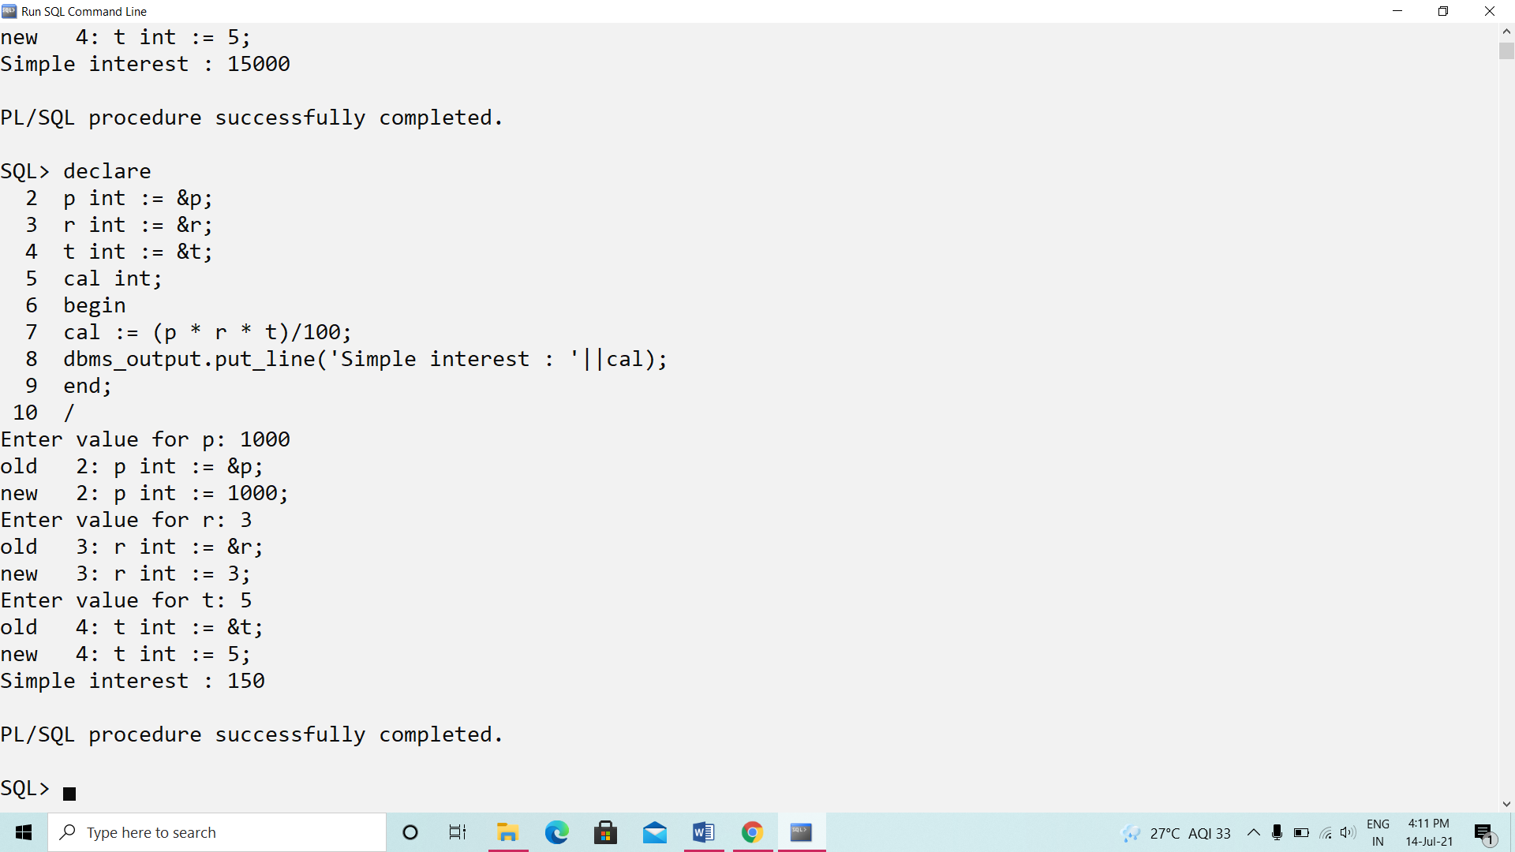

1. Write a PL/SQL block to calculate the area of the circle and store the radius and area in a table aoc.

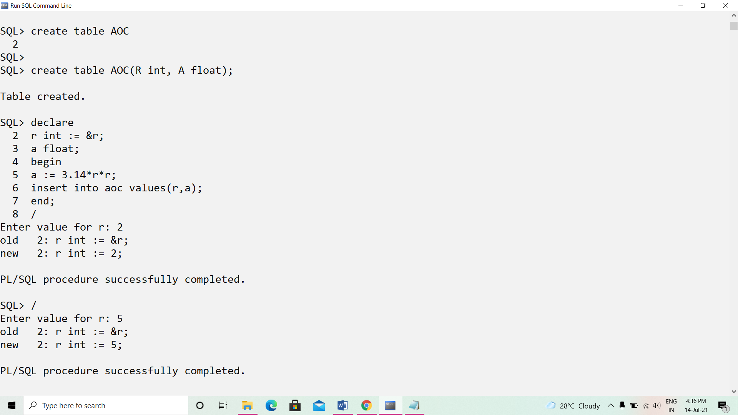

1. Write a PL/SQL block to print the total number of employees working as MANAGER in dept 10.

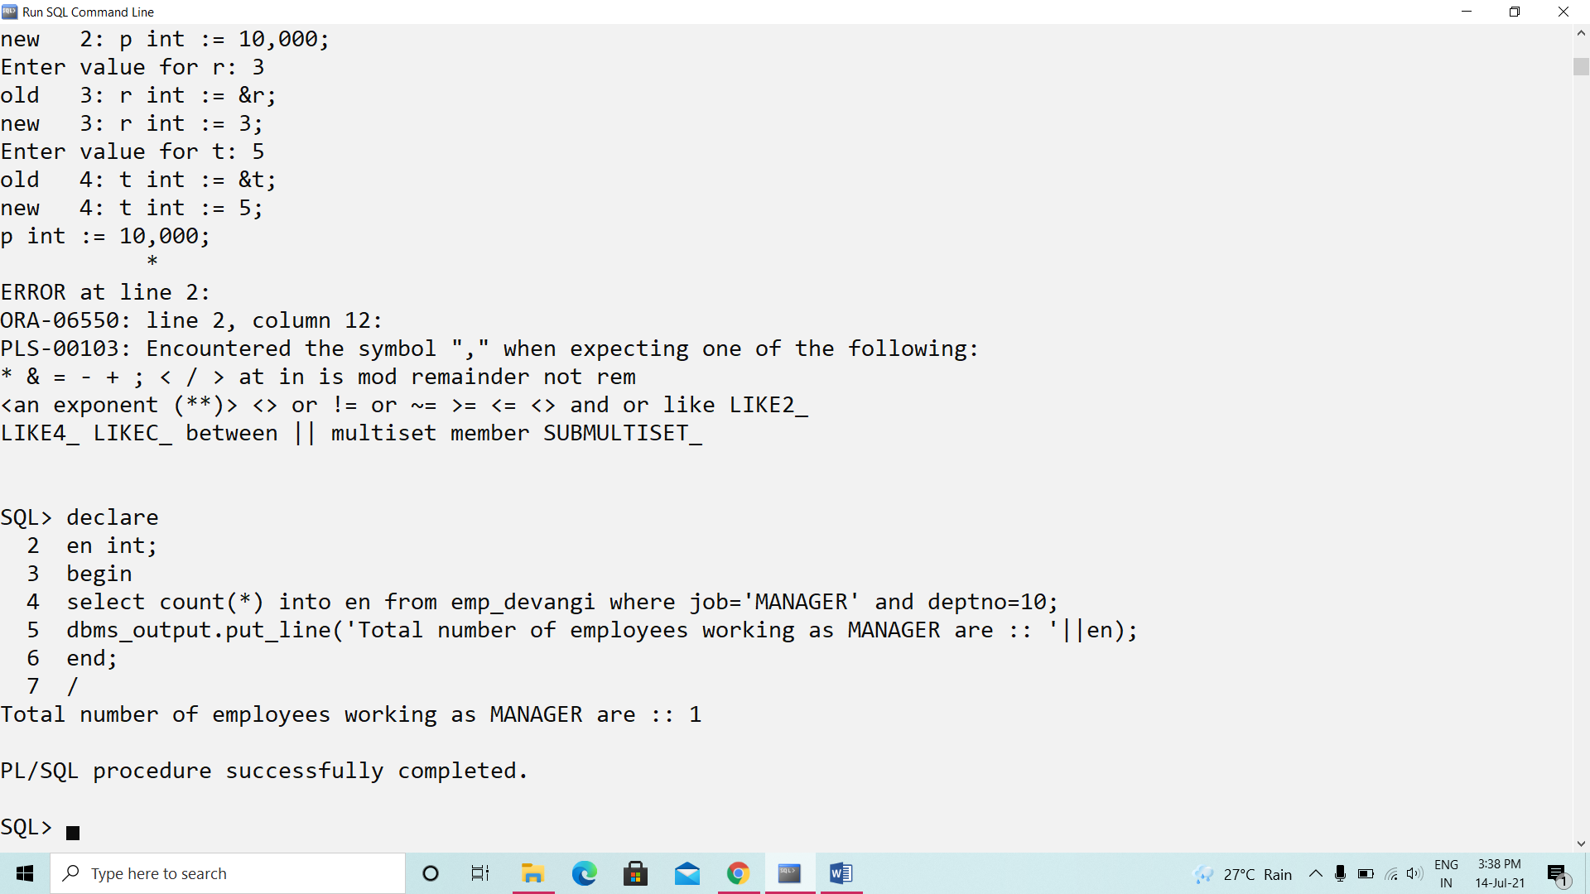

1. Write a PL/SQL block to print total salary of employees from the employee table

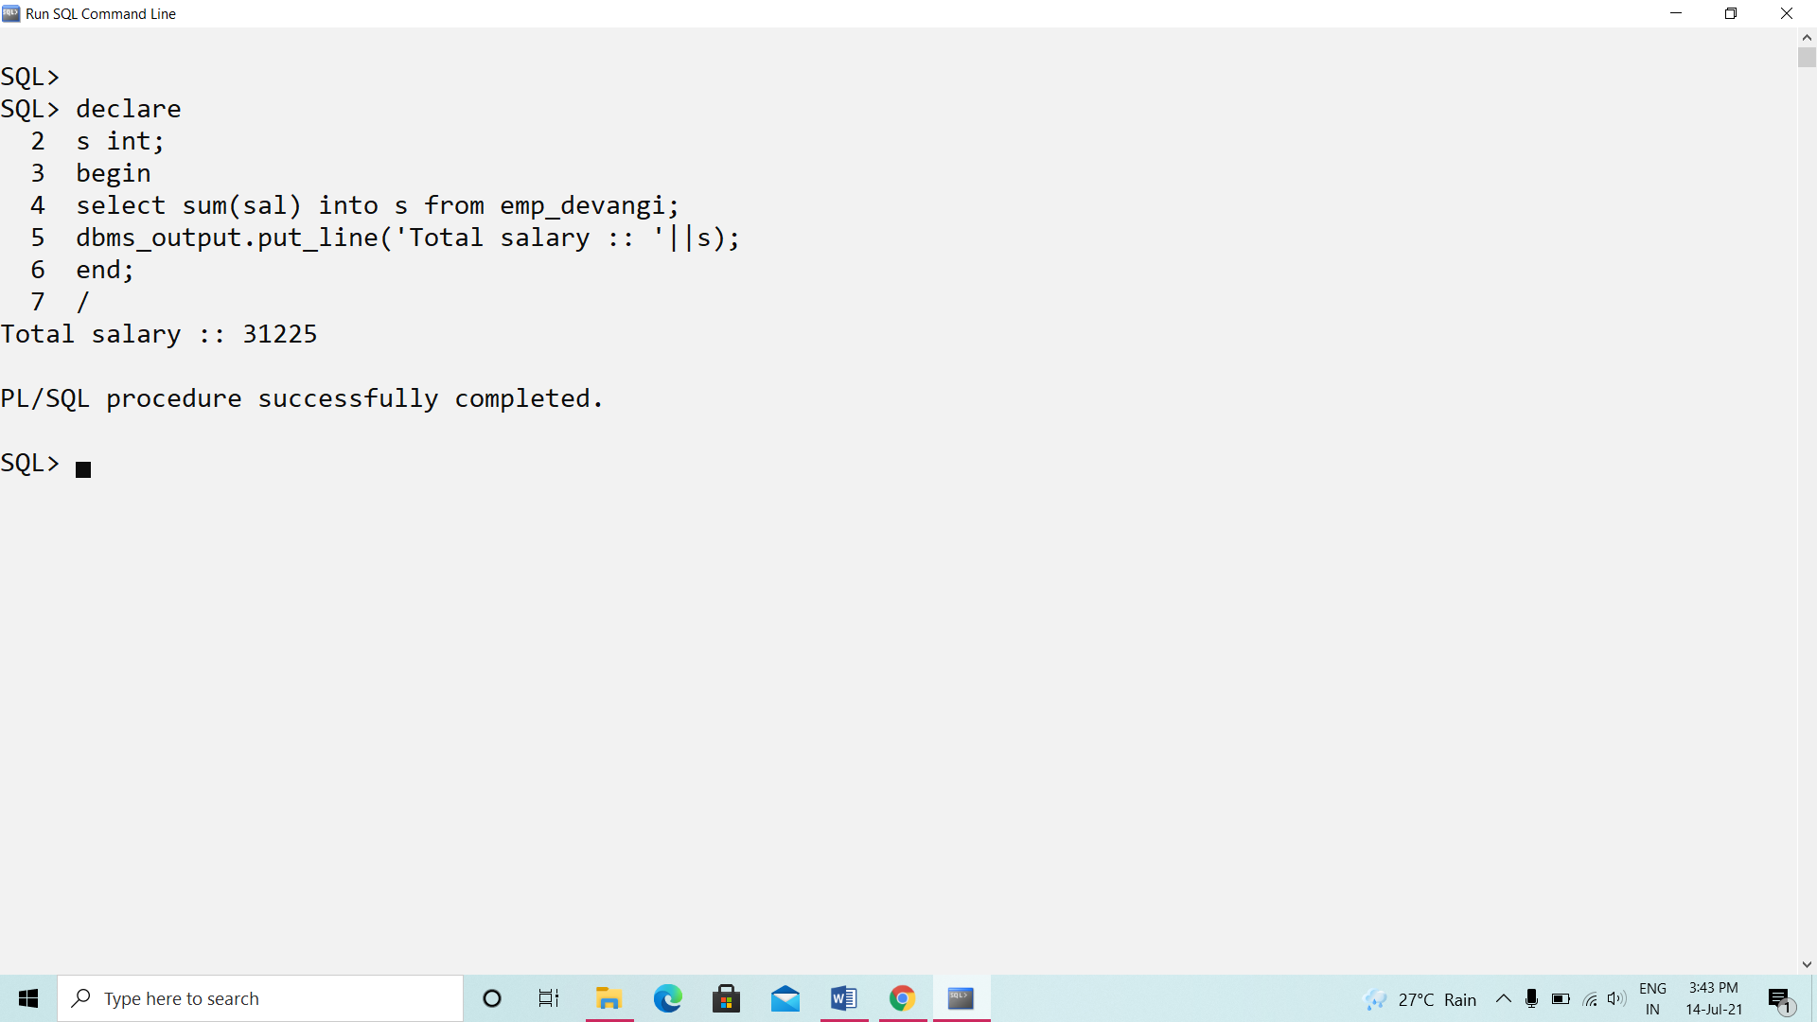

1. Write a PL/SQL block to find the cube of a number

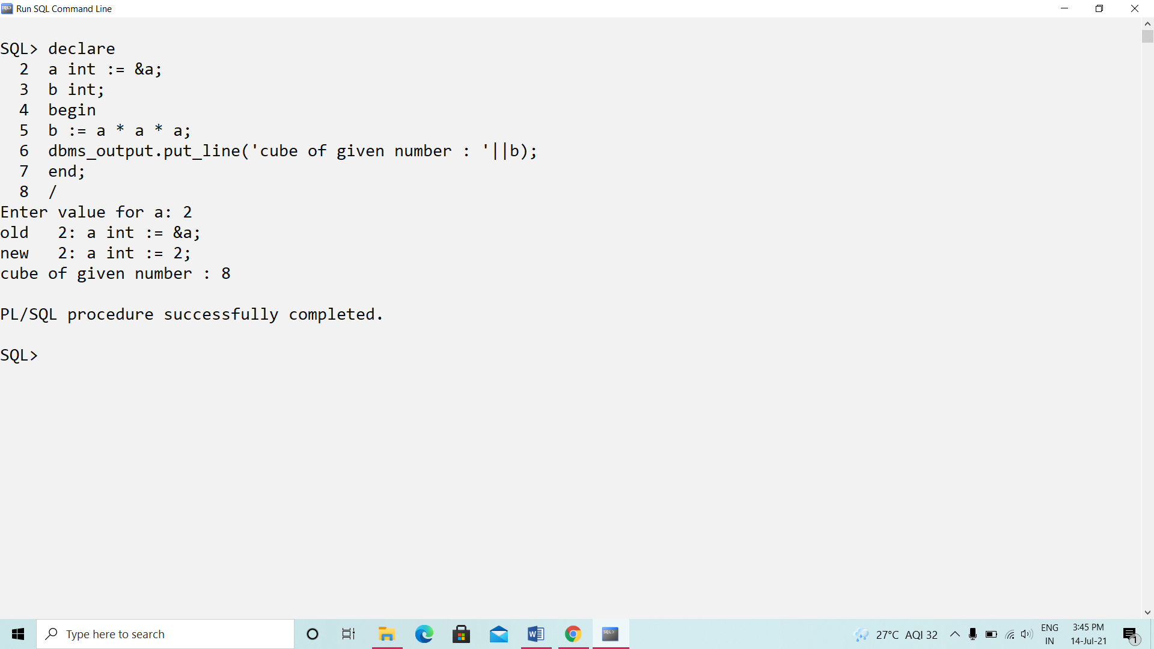

1. Write a block to print the message ‘I’m a user’

